Task …

Task 11:

Implement a program which (a) given a feature model or latent space, (b) a value n, (c) a value m, and (d) a label l

– creates a similarity graph, G (V, E), where V corresponds to the images in the database and E contains node pairs vi , vj such that, for each subject vi , vj is one of the n most similar images in the database in the given space.

– identifies the most significant m images (relative to the given label l) using personalized PageRank measure. See Huang, S., Li, X., Candan, K. S., Sapino, M. L. (2016). Reducing seed noise in personalized PageRank. Social Network Analysis and Mining, 6(1), 1-25.

**For the latent spaces FC:**

Params: label = 0, m = 5, n = 10:

Input Label Visualization:



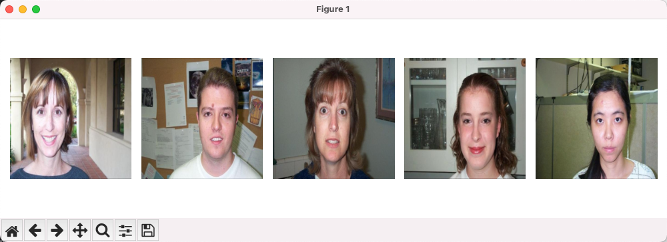

Param: label = 20, m = 5, n = 10:

Input Label Visualization:



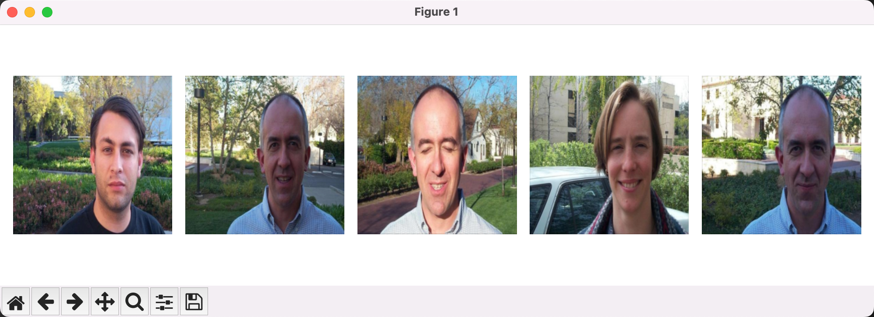

Param: label = 55, m = 5, n = 10:

Input Label Visualization:



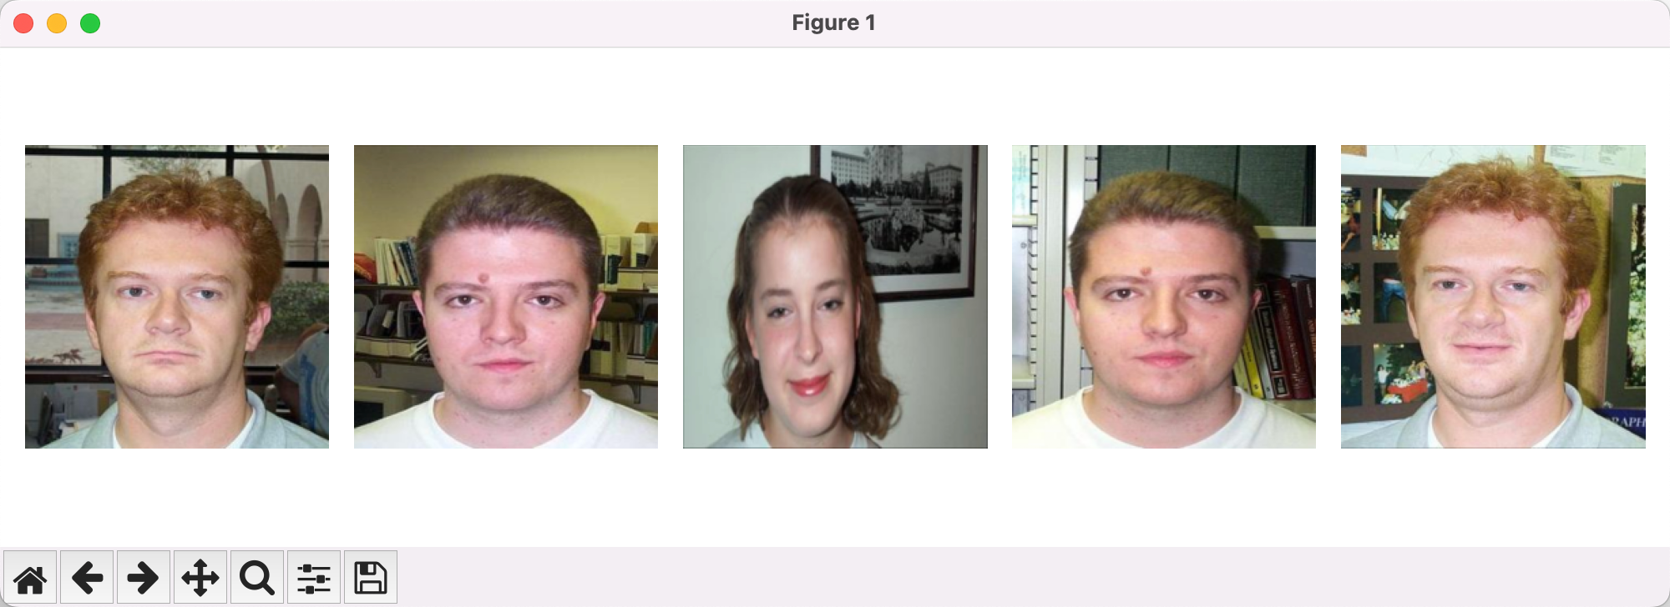

Param: label = 100, m = 5, n = 10:

Input Label Visualization:



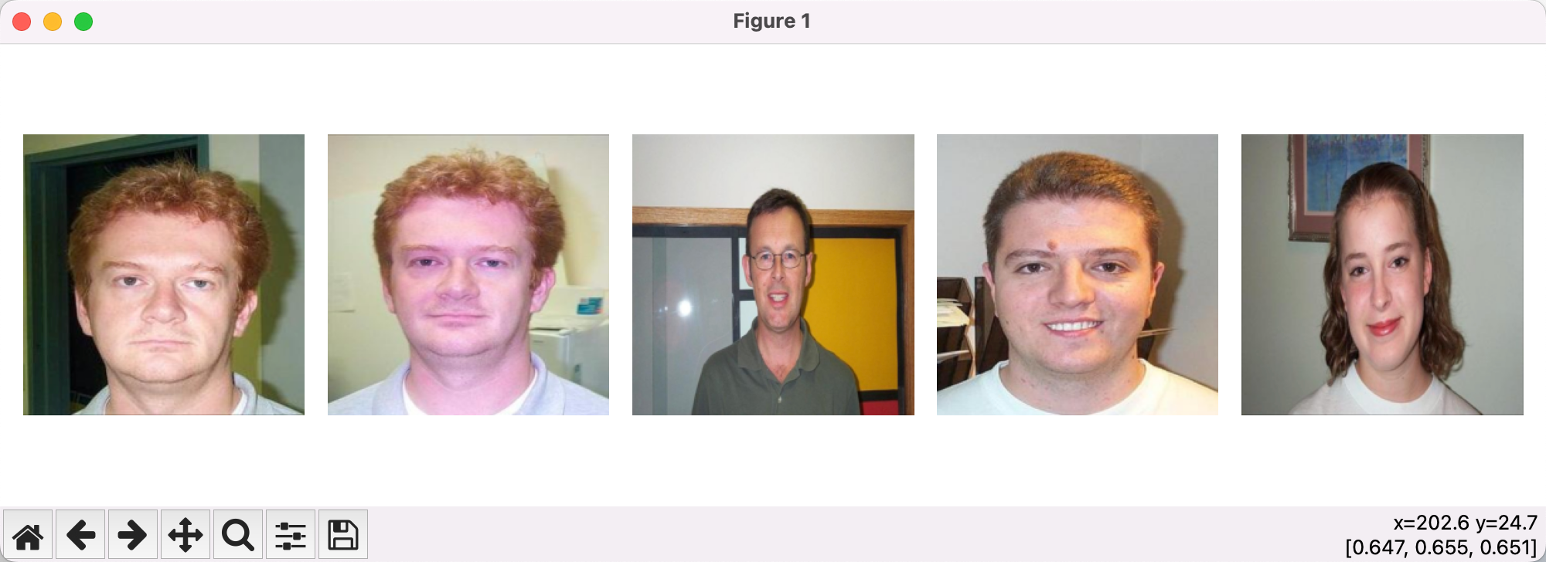

**For the latent spaces FC:**

Params: label = 0, m = 5, n = 10:

Input Label Visualization:



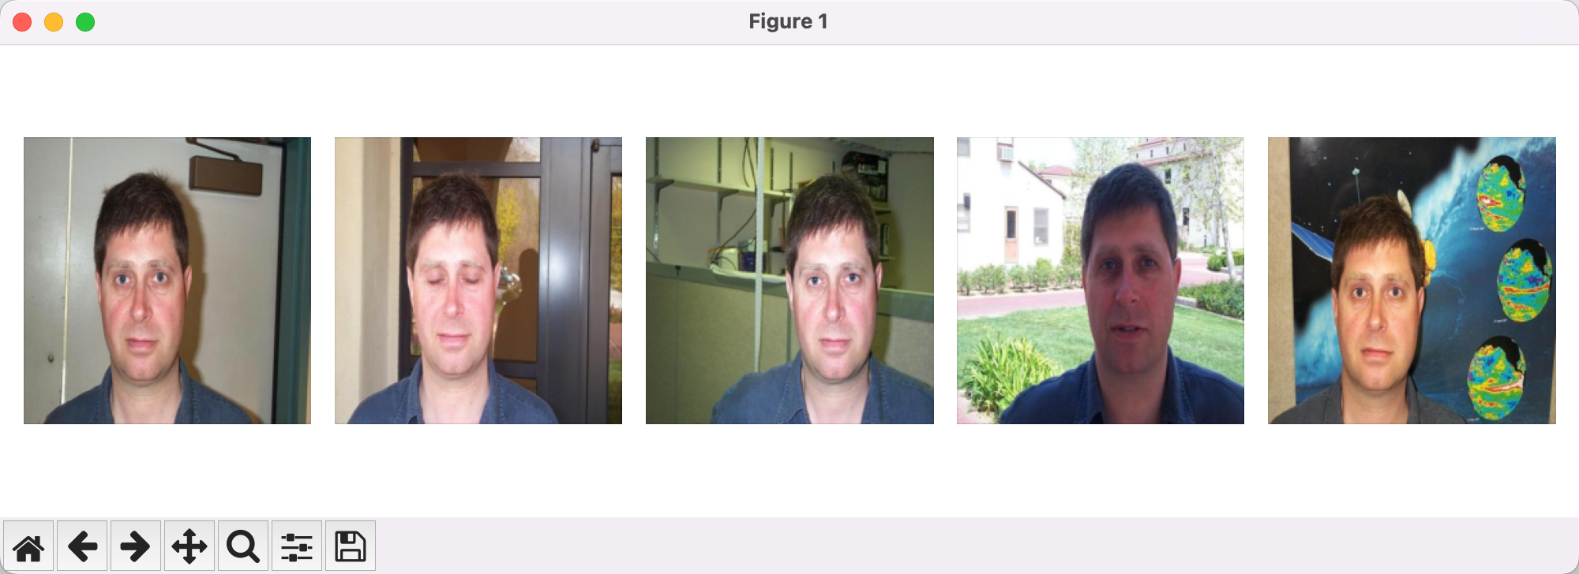

Param: label = 20, m = 5, n = 10:

Input Label Visualization:



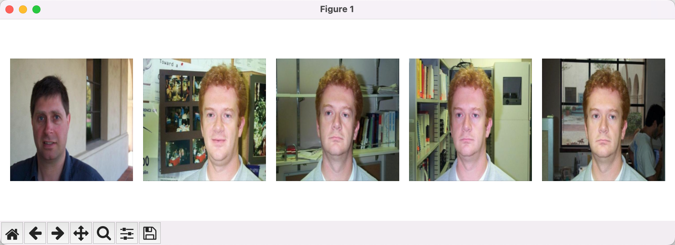

Param: label = 55, m = 5, n = 10:

Input Label Visualization:



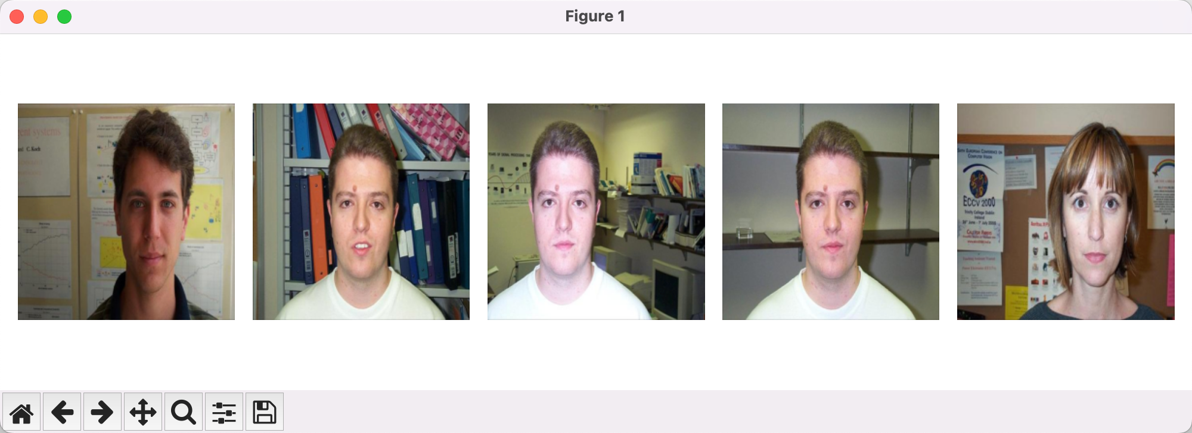

Param: label = 100, m = 5, n = 10:

Input Label Visualization:



